 

Assignment -4

|  |  |
| --- | --- |
| **Student Name/ID Number:** | I Kadek Adi Astawa/020 |
| **Academic Year:** | 2021/2022 |
| **Unit Assessor:** |  |
| **Project Title:** | Assignment 4 |
| **Issue Date:** | February 1, 2023 |
| **Submission Date:** | February 1, 2023 |
| **Internal Verifier Name:** |  |
| **Date:** |  |

|  |
| --- |
| **Learner declaration** |
| I certify that the work submitted for this assignment is my own and research sources are fully acknowledged.  February 1, 2023  Student signature: Date: |

Let’s build on the previous assignment. (Develop “Know-Your-Neighbourhood”) application. The goal of this application is to provide details on all stores in the user’s neighbourhood.

1. Create a Spring Boot application for “Know-Your-Neighbourhood”.

* Click file window > new > Spring Starter Project

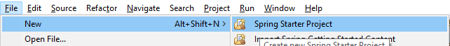

* Fill the form

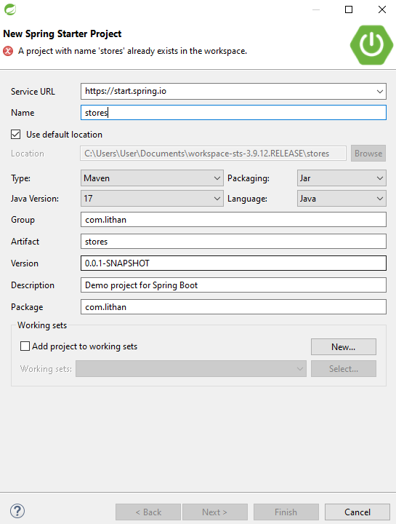

* Type web and select Spring Web

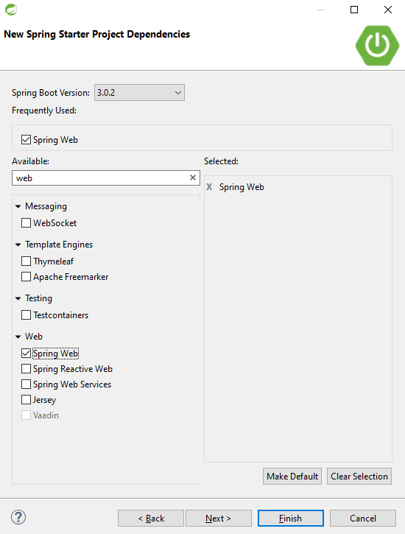

1. Add support for JSP views and create required folder structure.

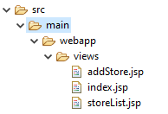

1. Move already developed classes into this project.

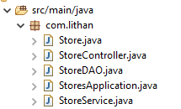

1. Create store table in the database

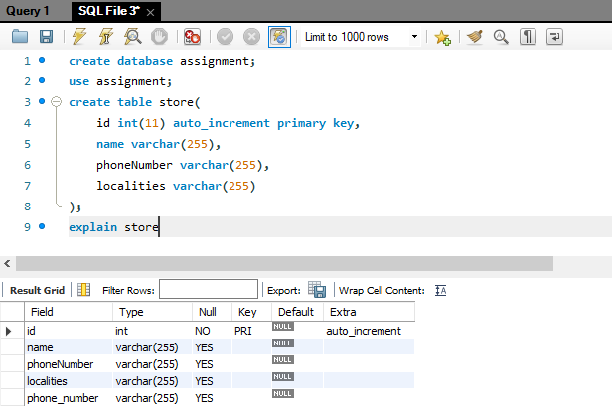

1. Annotate all the fields of Store object appropriately.

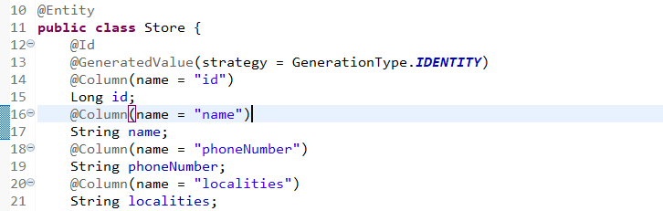

1. Develop all components required to view the stores
2. Add method to existing Controller class to receive the request to fetch stores

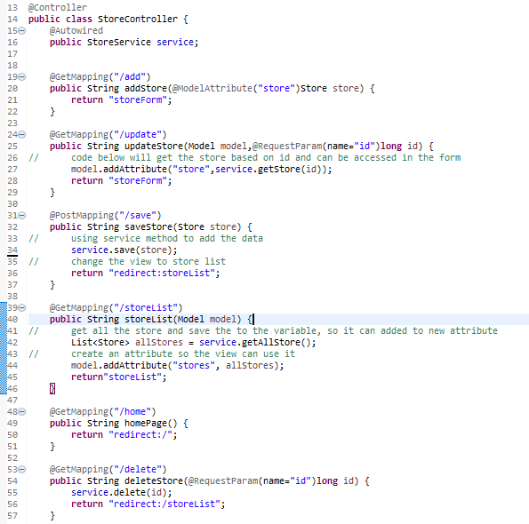

1. Enhance Store service and Store Controller objects to support CRUD operations on store object.

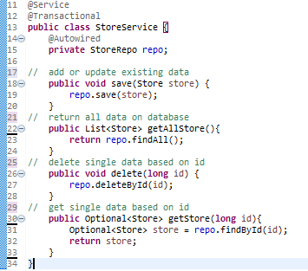

1. Add method existing repository class to perform crud operations on Store object.

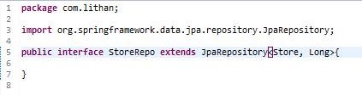

1. Create HTML to view the stores. Show name, phone number and localities it serves for each store.

StoreList.jsp

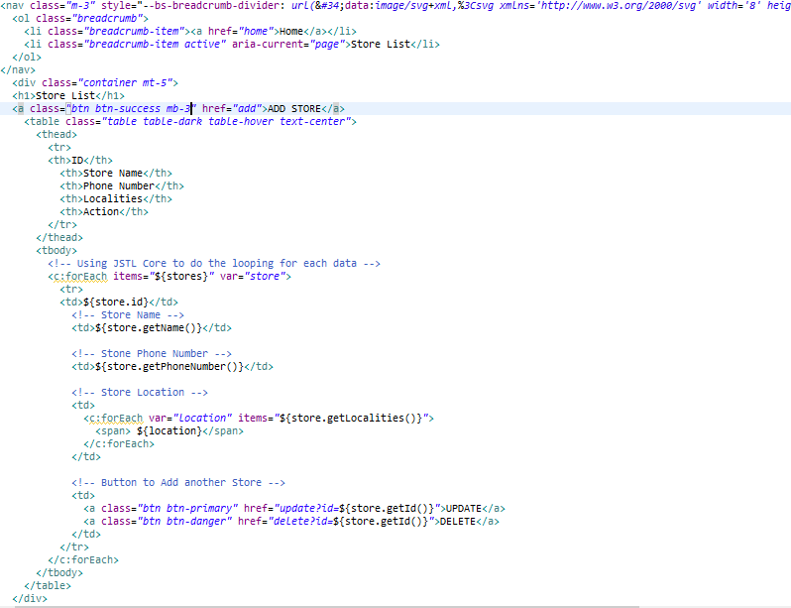

Store List Page

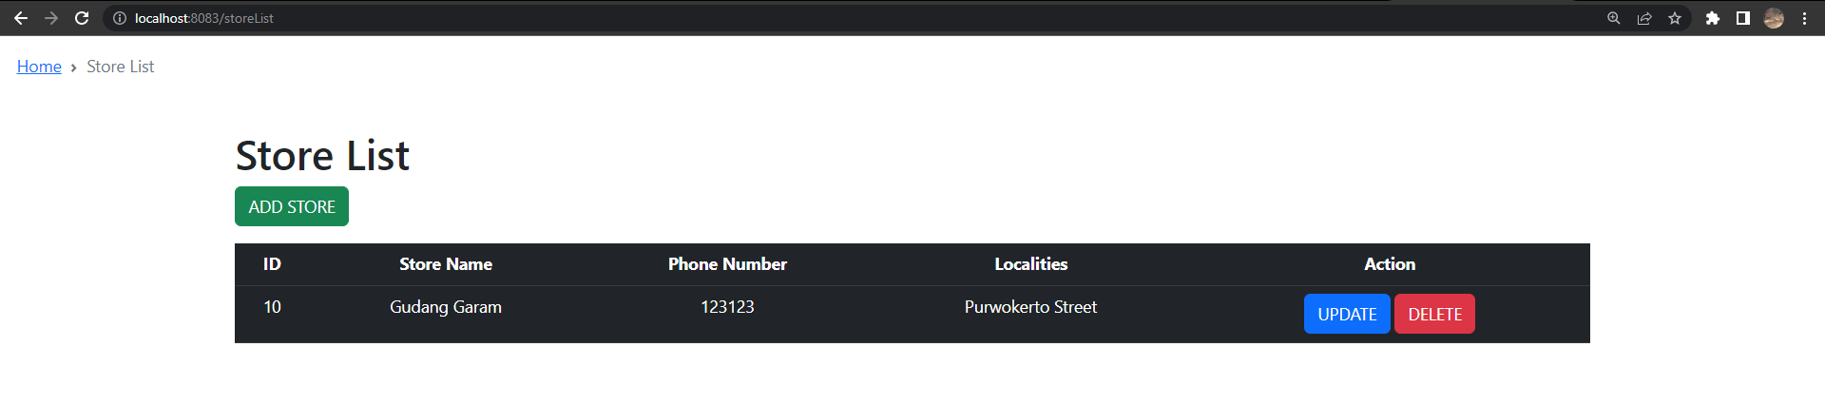

1. Ensure that view stores request works end-to-end. (i.e., should be able to submit request to view the stores in the browser and get the page back with all stores).

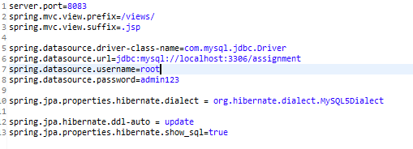

Database :

